Report by: 1409046  
Role: Level Design & Artist liaison

Game Version: Latest – with Menus  
Date Reported: 30/04/2016

QA Status: Passed

Severity: Minor

Priority: Low

Test Introduction:

The purpose of this test was to check that the camera was working correctly and displaying what I wanted. To test this, I placed the camera where I thought it would be most effective and pressed play.

Expected outcome:

The camera would show aspects that I wanted it to show.

Actual outcome:

When I played the game the camera would display some of the content that Is below the floor.

Screenshot of the bug:

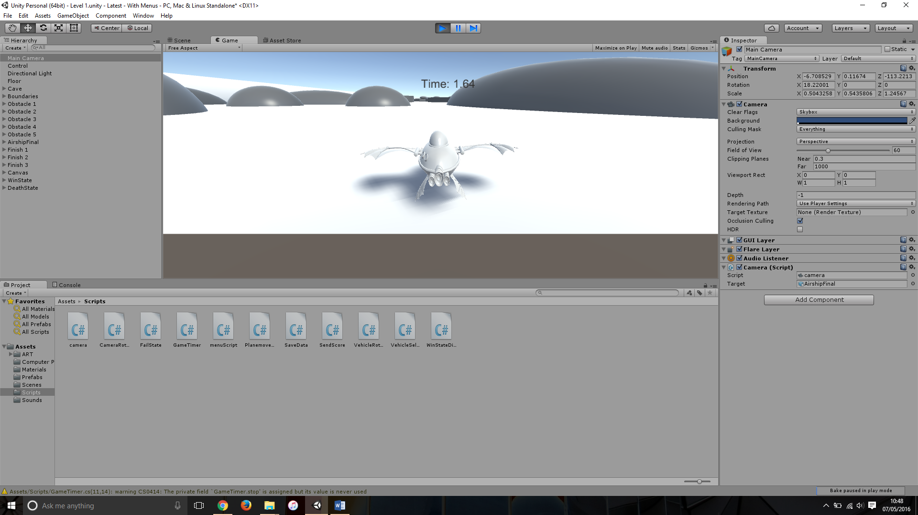

Image showing the camera displaying unwanted content.

Potential cause:

A potential cause for this bug could be that the script isn’t registering the floor as an object as it is too close to it.

Another cause for this bug could be that because the camera is so low, it will shoot some of the content below this line as that is what the camera sees

Suggested Fix:

To fix this bug I had to raise the camera so it was not too close to the floor, this also meant that there was no way the it could see below the floor.